***Mobile App Overview***

1. This is a green-field project.
2. The application will be similar to ***Zomato*** but with 2 additional points.

***A section for promotions in the restaurant profile page.

***Landing page - User will be shown all of the promotions and ability to search promotions.

1. Preview Link - https://www.fluidui.com/editor/live/preview/cF9QMTB1UG9hN0s1SlBWdDJSUmd1Wk9TT2FUT1AxR2JGZA==

***Functional Scenarios (FS):***

**As a User**

1. Ability to see, filter and sort all promotions (card offers, Discounts, Buy 1 Get 1) of restaurants in the home page.
2. Ability to click on the promo and see the restaurant profile.
3. Ability to view and search for all restaurants.
4. Ability to create an account (Maybe later).
5. Ability to review a restaurant (Maybe later).
6. Ability to book a restaurant (Maybe later).

***Specifications:***

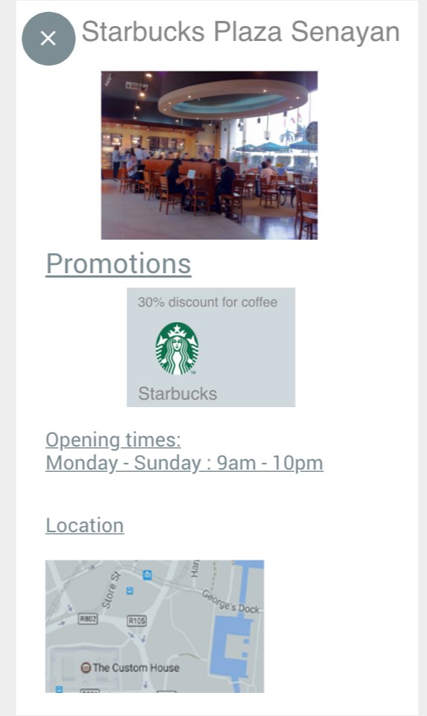

**Restaurant:**

1. Opening times.
2. Profile Picture.
3. Menu Pictures.
4. Cover pictures.
5. Restaurant Promotions.

**Restaurant Promotion:**

1. Promotion Type - Food, drink or alcohol.
2. Promotion Category - Discount, BOGO or Special price.
3. Valid Time.
4. Valid Date.
5. Promotion requirement - Credit card, debit card and etc.

